CC Assignment 2
Neeti Kurulkar
Install and Configure Google App Engine

- Install Google Cloud SDK and Sign In

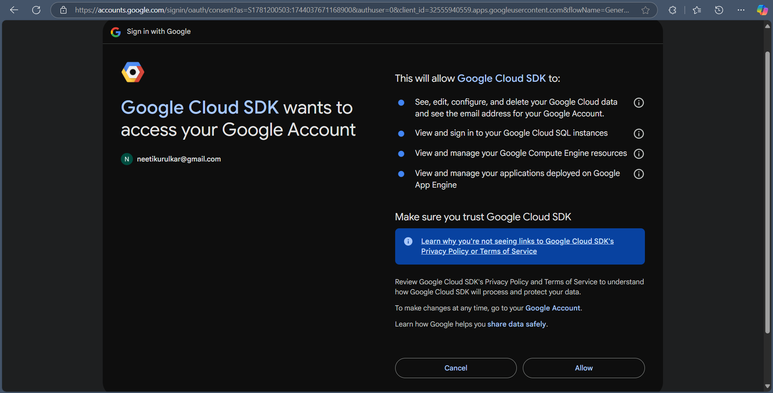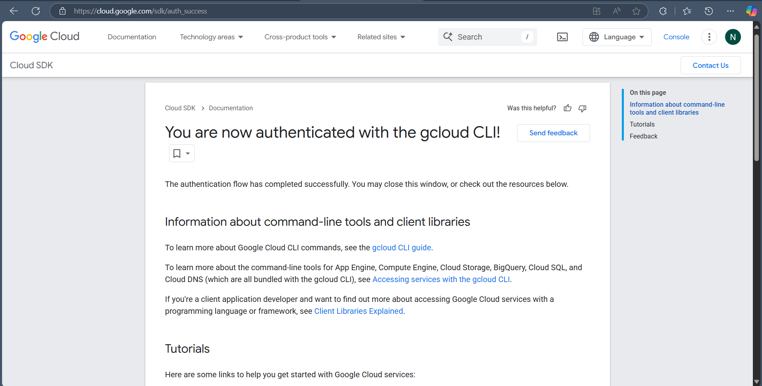

- Install Google App Engine using Google Cloud CLI

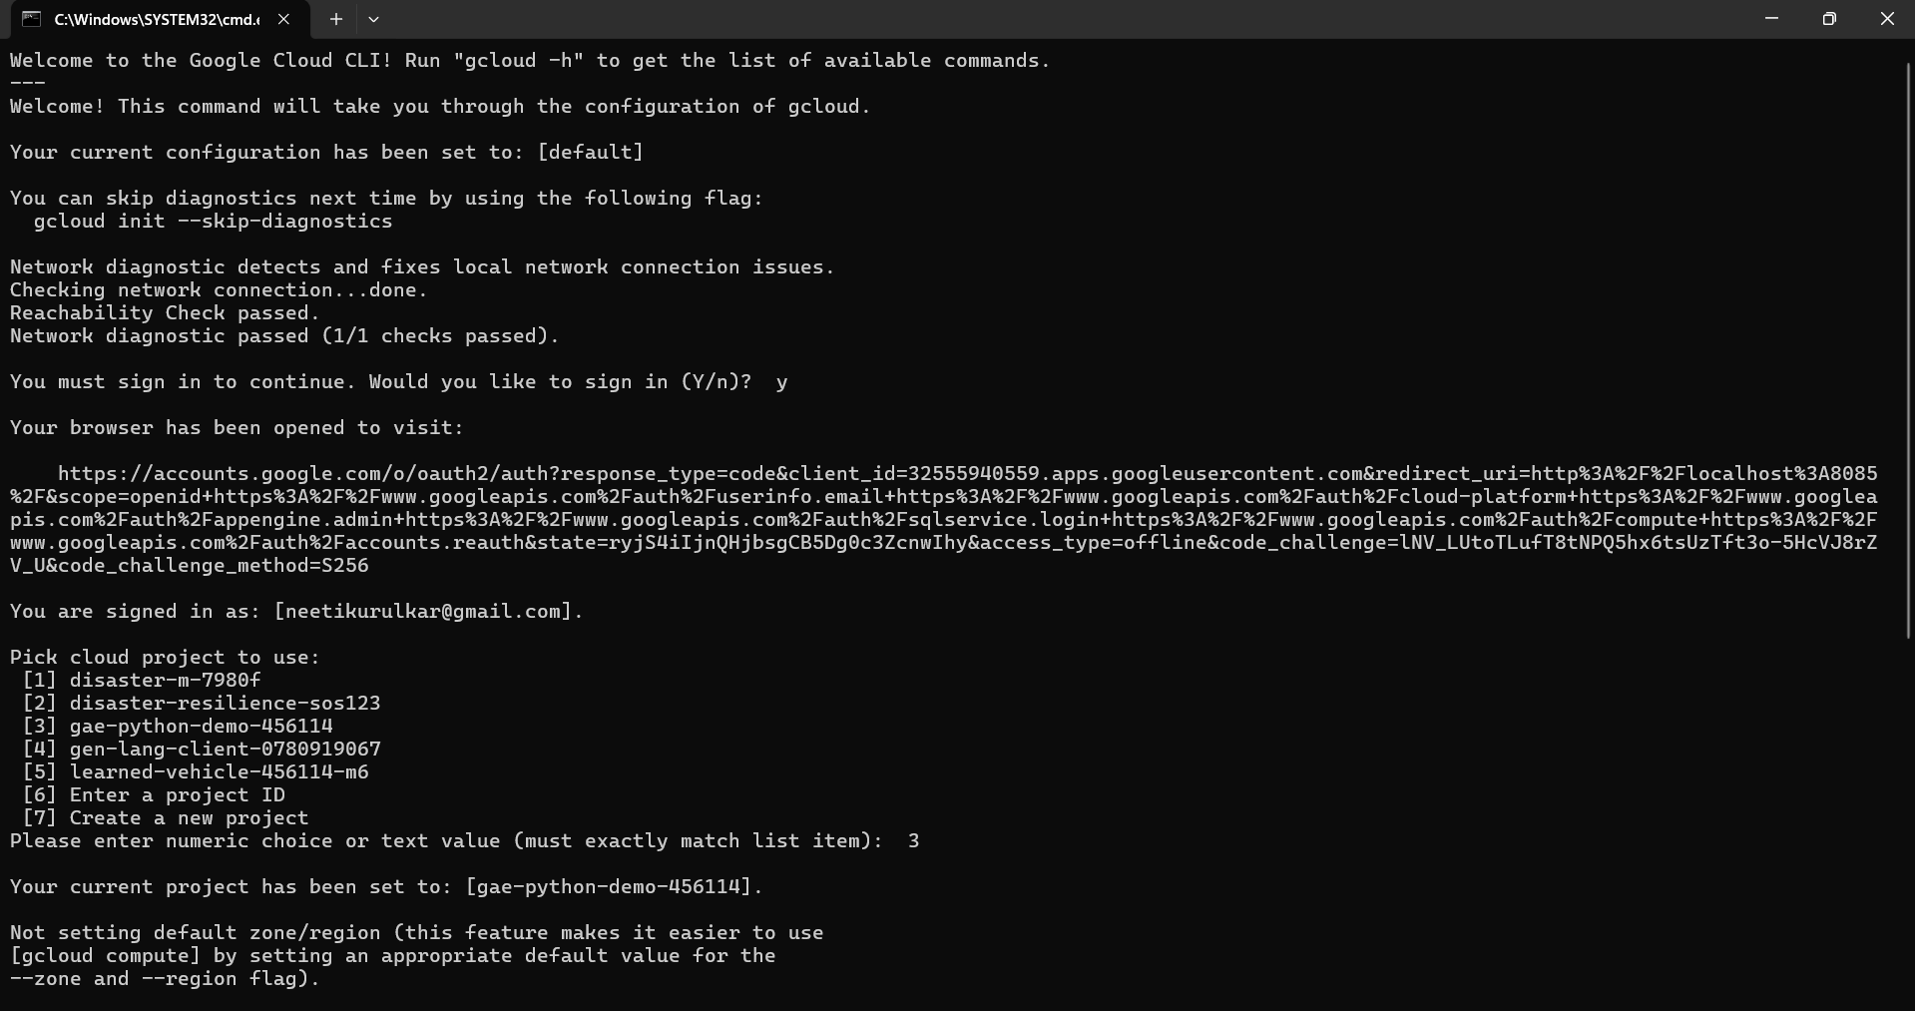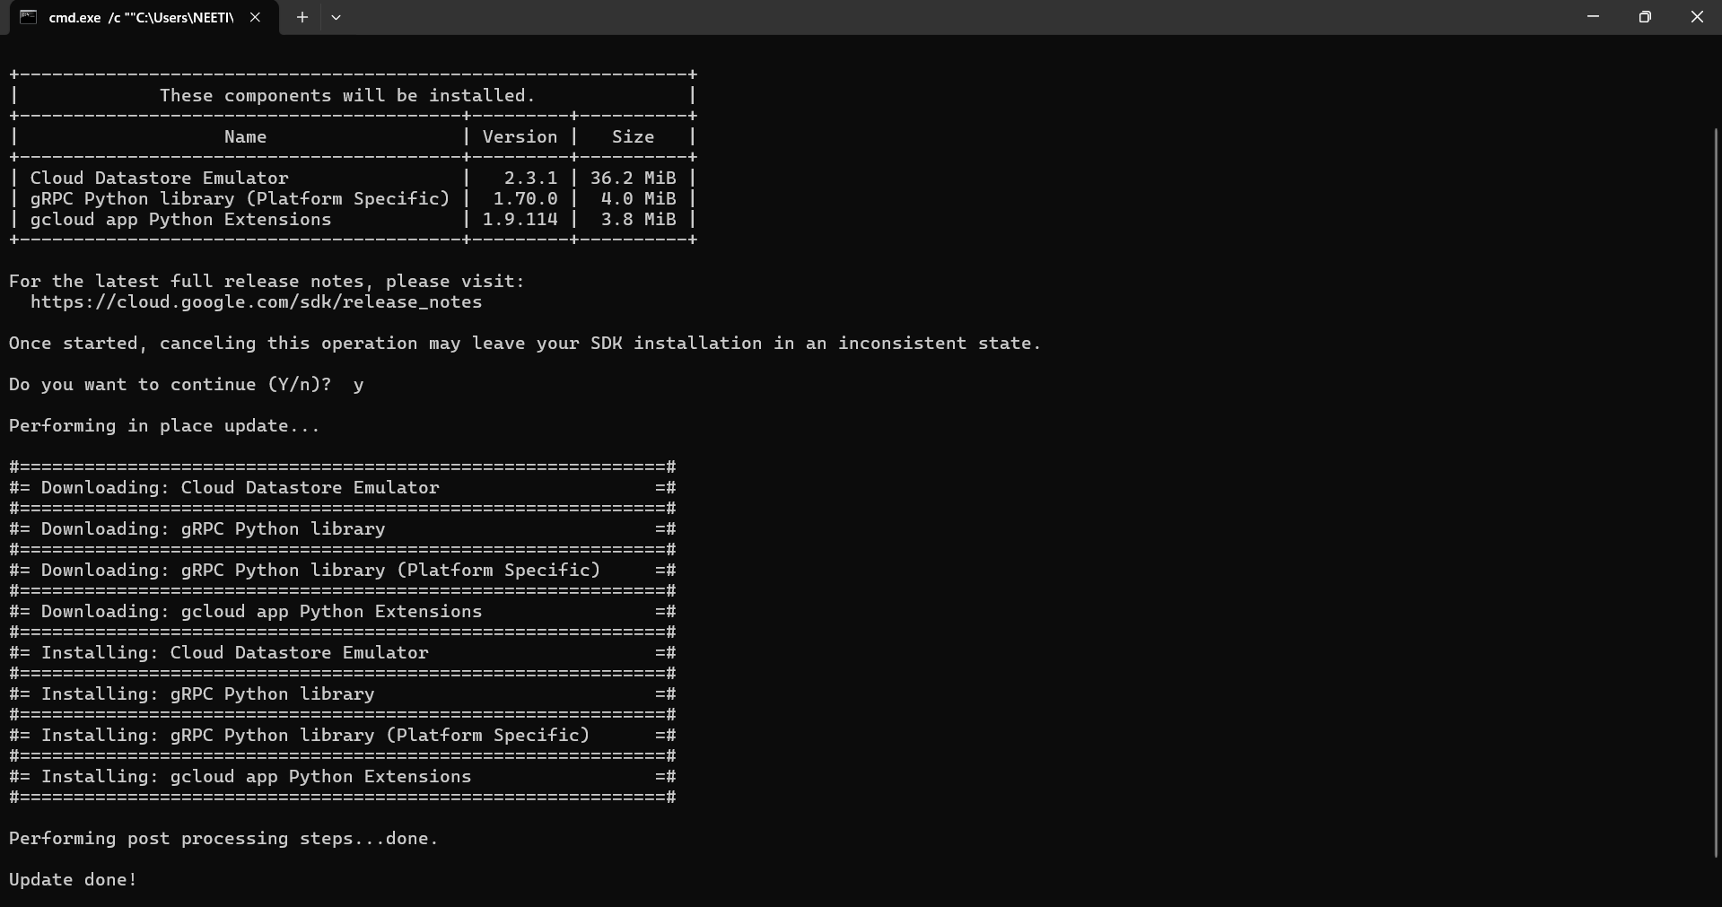

- Create new project in Google Cloud Console

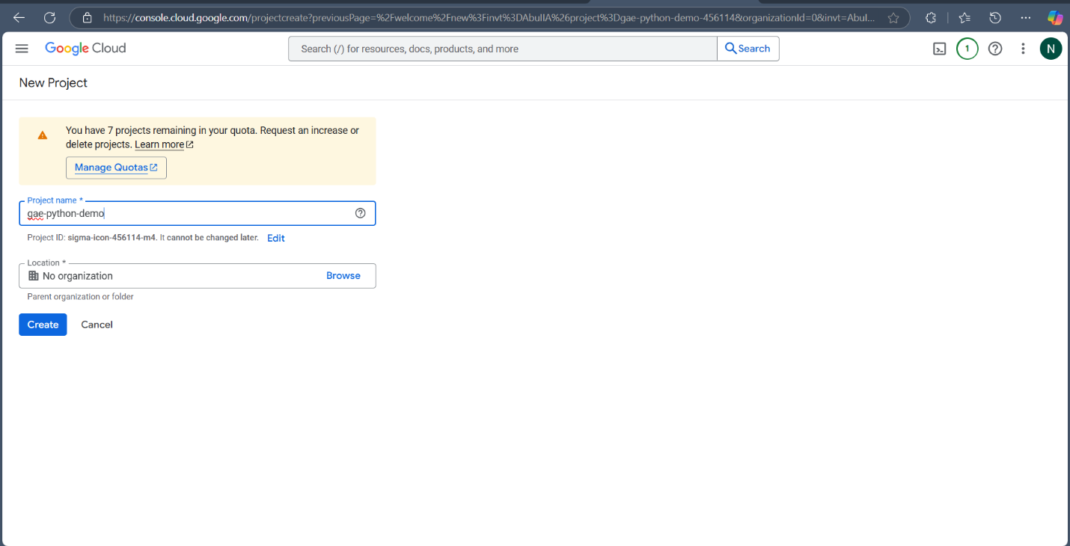

- Codes:
  - App.yaml

runtime: python39

handlers:
- url: /.*
script: auto

  - Main.py

from flask import Flask
app = Flask(__name__)

@app.route('/')
def hello():
return "Hello, App Engine!"

  - Requirements.txt
Flask==2.3.2

- Deploy app

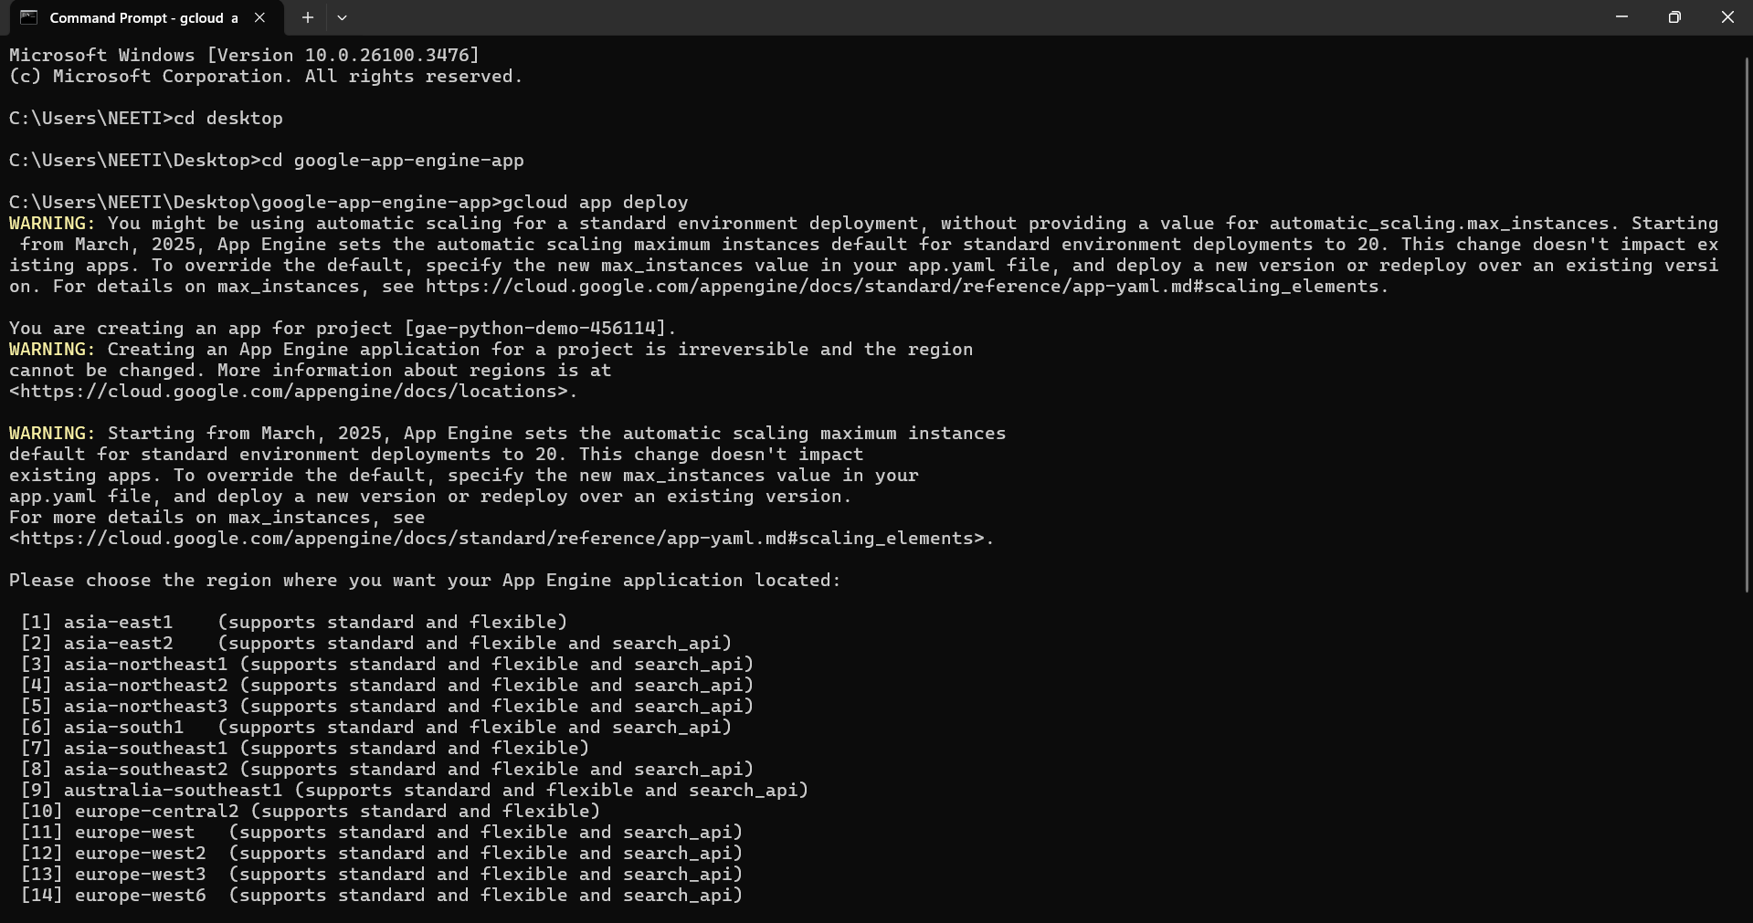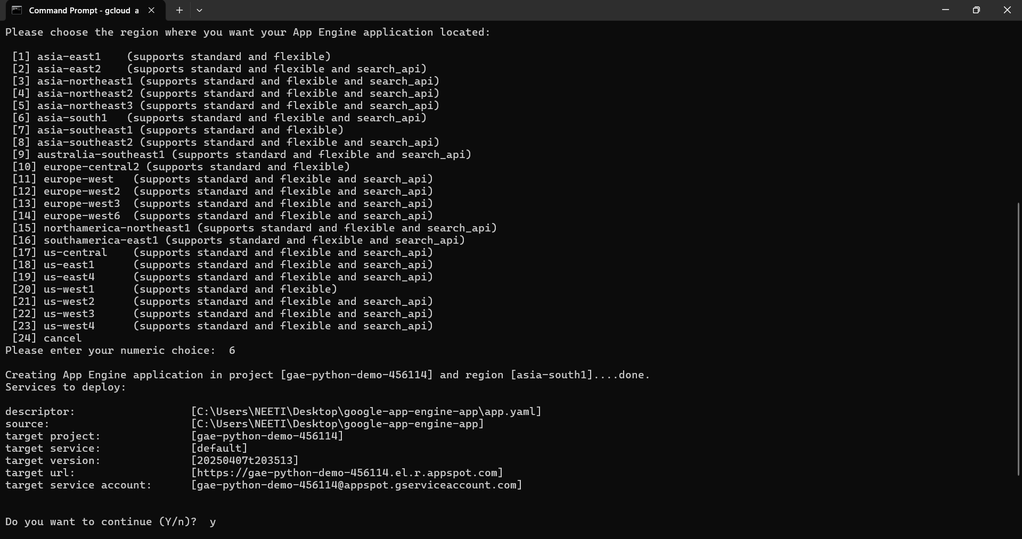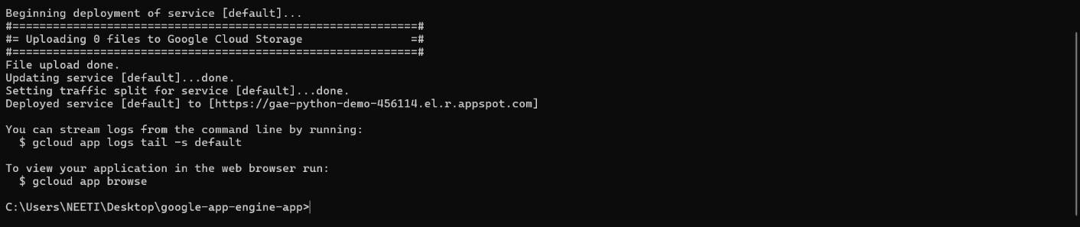

Output:

